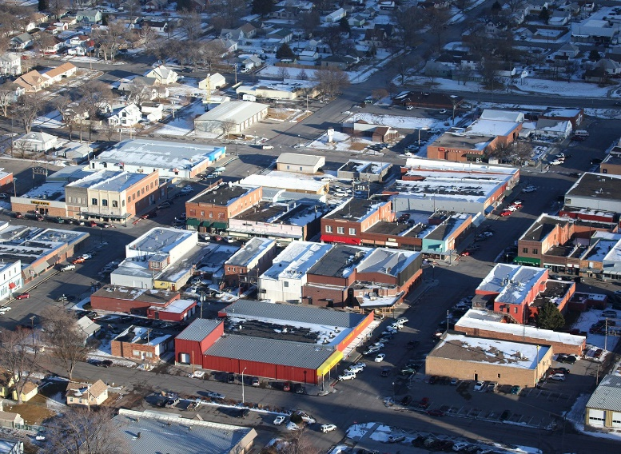
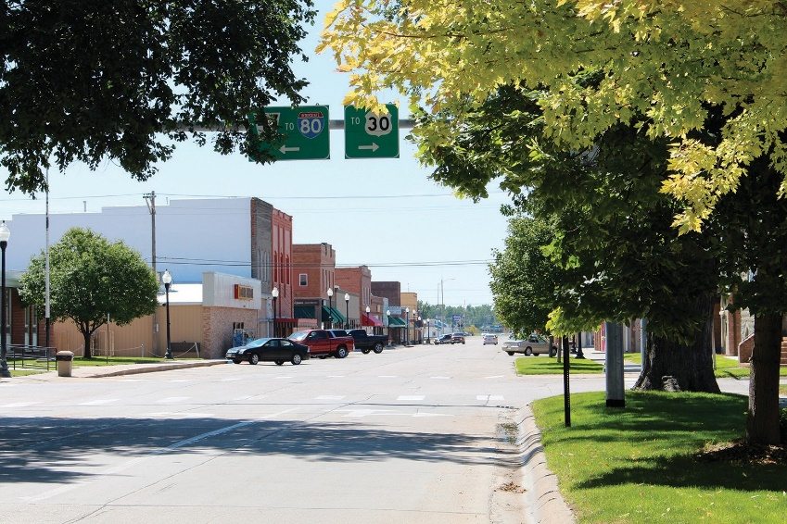

Nebraska Digital Inclusion Plan
Template
July 2021

Digital Inclusion Committee Members
Insert the list of Digital Inclusion Committee Members
Goal Statement or Vision Statement
Include a goal or vision statement describing what your community, county, or region hopes to achieve.

Broadband Availability, Computing Devices & Broadband Subscription
Broadband Subscriptions at Home
Include information on the percent of population with a broadband subscription in your county and in Nebraska.
Percent Population with a Broadband Subscription
By Age Group
Area | % Population | % Population Under 18 | % Population 18-64 Years | % Population 65 Years and Over
Adams County | 86.0% | 93.4% | 89.2% | 65.8%
Nebraska | 88.1% | 93.1% | 90.5% | 70.1%
Date of ACS 5-Year Data: 2019

You can also include a chart showing broadband subscription information.
Include a short narrative discussion about broadband subscription. You may want to address the questions below:
- Is the percent population with a broadband subscription in your county higher, lower or about the same as the figures for Nebraska?
- Do you agree with these estimates? If not, why do you think these estimates are inaccurate?
- If the figures for your county are significantly different than the figures for Nebraska, what factors are contributing to the differences?

Include a table showing the population without broadband. A sample table for Adams County follows:
Population without a Broadband Subscription
By Age Group
Age Group | Population | % Population with Broadband Subscription | % Population without Broadband Subscription | Population without Broadband Subscription
Total Population | 31,363 | 86.0% | 14.0% | 4,391
Under 18 | 7,339 | 93.4% | 6.6% | 484
18-64 | 18,096 | 89.2 | 10.8% | 1,954
65 and over | 5,928 | 65.8 | 34.2% | 2,027
Date of ACS 5-Year Data: 2019

You can include a chart of the population and a brief discussion including which age group has the largest population without a broadband subscription.

Include a table showing the percent of households in your county and in Nebraska with broadband, mobile only and satellite subscriptions. A sample for Adams County is included below.
Percent Households with Broadband, Mobile Only and Satellite Subscriptions
Area | % Households with Broadband Subscription | % Households with Mobile Only | % Households with Satellite Subscription
Adams County | 78.7% | 9.2% | 7.0%
Nebraska | 83.4% | 10.1% | 6.5%

Include a brief discussion of this information. You may want to address the following questions:
- Are there significant differences in the subscription rates for your county and for Nebraska? If so, what factors are likely contributing to the difference?
- Does your county have a higher mobile only or satellite subscription rate than Nebraska? Mobile and satellite broadband subscriptions often include data limits. Mobile broadband only subscribers may not have a connected computer in the household which may impact the ability of members of the household to complete homework, apply for jobs or work at home.
Computers, Tablets and Smartphones in Households
Include a table showing the number of households and the % of households in your county with computing devices, smartphones only, and no computing device. Here is a sample table for Adams County.
Households and % Households in Adams County
with Devices, Smartphone Only or No Computer
2019 ACS 5-Year
 | # of Households | % Households
With one or more computing devices | 11,128 | 87.5
With smartphone only | 920 | 7.2
With no computing device | 1,584 | 12.5

Include a chart comparing the figures for your county and f or Nebraska. Here is a sample chart for Adams County.

Include a brief discussion of this information. You may want to address the following questions:
- Do the figures for your county mirror the figures for Nebraska or are they significantly different?
- If they differ from the statewide average significantly, what factors are contributing to the difference?

Broadband Availability
Include a table and chart with information on percent population with broadband availability in your plan. Here is a sample for Adams County.
Area | % Population  with 25/3 Mbps | % Population  with 100/10 Mbps
Adams County | 96.7% | 94.5%
Rural Adams County | 86.3% | 76.8%
Nebraska | 98.3% | 90.2%
Rural Nebraska | 93.9% | 68.2%

Include a brief summary of these discussion points:
- Is the percent population and percent rural population with broadband available in your county higher, lower or about the same as the figures for Nebraska?
- Do you agree with these estimates? If not, why do you think these estimates are inaccurate?
- If the figures for your county are significantly different than the figures for Nebraska, what factors are contributing to the differences?

Broadband Availability Map
Insert a screenshot of a map of broadband availability for your county, community or region from https://broadbandmap.nebraska.gov. A sample map showing the Tri-Cities area is shown below.

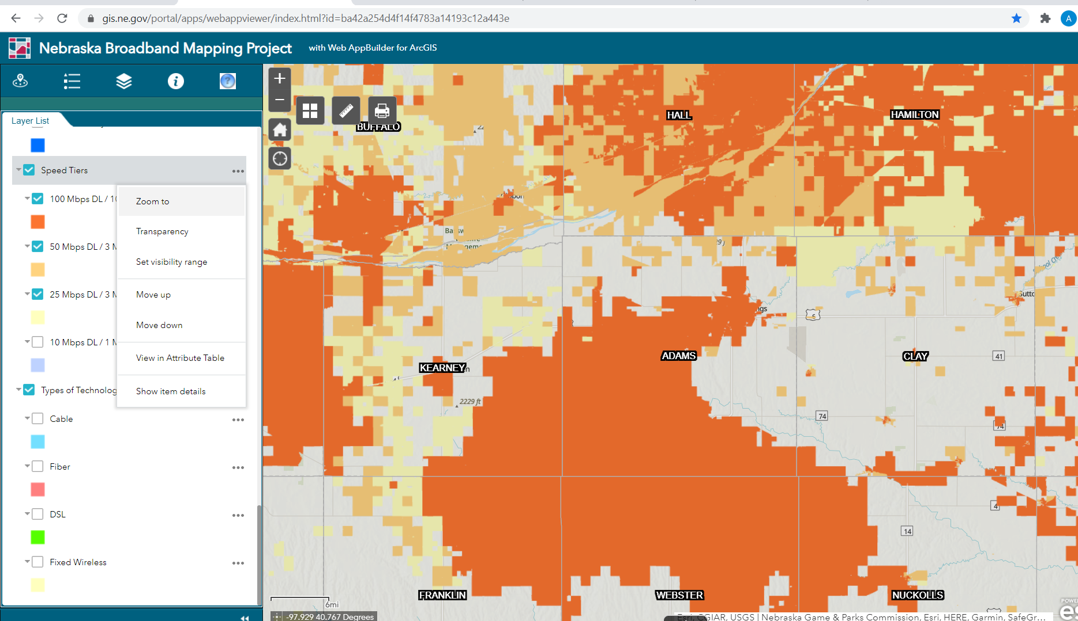
Include a short narrative discussing the broadband map. You may want to address the questions below:
- Do telecommunications providers report providing broadband to all areas of your community or county?
- Does the information reported by telecommunications providers seem accurate? Are there areas where broadband availability is overstated?
- Which companies provide broadband in your area?

Broadband Speed Test Map
Insert a screen shot of the speed test map (https://www.nebraskaspeedtest.org/) of your community, county or region in your plan. Here is a map of Custer County’s speed tests as a sample. 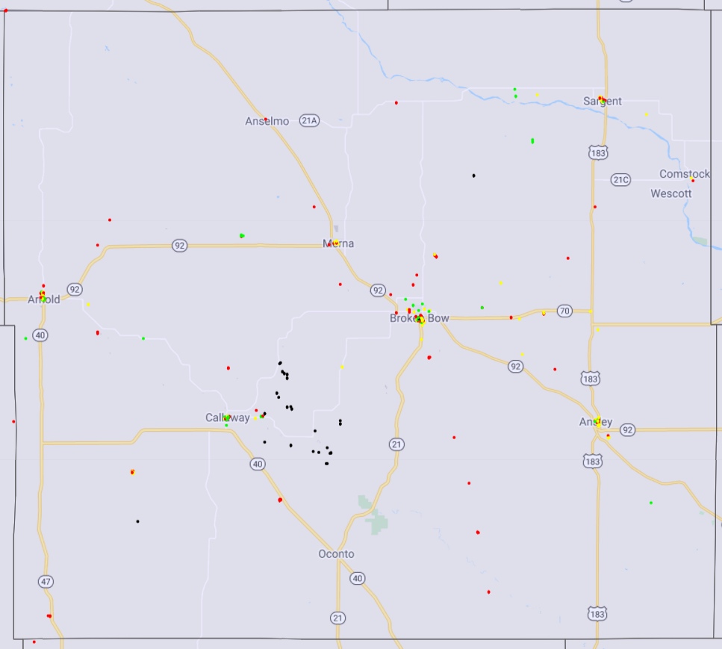
Include a short narrative discussing the broadband map and speed test map. You may want to address the questions below:
- Compare how the Nebraska Broadband Map and the Nebraska Speed Test map visualize broadband availability. Which one do you think more accurately shows broadband availability in your county or community?
- What areas of your community, county or region do not have broadband available?

Broadband Affordability
Include a short narrative discussing broadband affordability. You may want to address the questions below:
- How affordable is broadband service?
- Do providers offer lower cost service to low income consumers?
- Is information on federal and state programs which provide assistance to low-income consumers easily available to individuals and families that may qualify?

Why aren’t individuals digitally connected?
What are their needs, interests and challenges?
Include a short narrative discussing broadband affordability. You may want to address the questions below:
- What are the main reasons that individuals in my community are not digitally connected? What are their needs, interests, and challenges?
- How does technology fit into everyday life? Why learn?
- What are the social, emotional and human needs of people who are getting up to speed with broadband, technology and digital skills?
- Is technology a threat to identity? How can we maintain community values?
- What is the best way to connect people with tools and resources to learn what matters

Digital Inclusion Assets and Gaps

Public Library Broadband and Assets
Public Library Broadband & Measures | Data
Download and upload speed of the public library’s internet service
Does the library have a fiber connection for broadband?
Does the library apply for E-Rate funding?
If the library does not have a fiber connection, has the library considered applying for the E-Rate Special Construction program and matching funds from the Nebraska Public Service Commission?
Include a brief summary of these discussion points:

Describe the public library’s digital inclusion assets and gaps.

K-12 Schools
Describe the digital inclusion assets and gaps of local K-12 schools.

Local Agencies on Aging or Senior Centers
Describe the digital inclusion assets and gaps of local agencies on aging or senior centers.
Other Programs
Describe the digital inclusion assets and gaps of other programs or organizations if applicable.

Actions, Strategies and Programs
Strategies and Programs that help those who don’t have broadband at home
Existing Programs and Resources that Can Be Leveraged
1.
2.
3.

New Strategies, Actions and Programs to help those who don’t have broadband at home
1.
2.
3.

Strategies and Programs that help those who don’t have a computer, tablet or smart phone
Existing Programs and Resources that Can Be Leveraged
1.
2.
3.

New Strategies, Actions and Programs
1.
2.
3.

Strategies and Programs to help those who lack skills knowledge, confidence and technical support
Existing Programs and Resources that Can Be Leveraged
1.
2.
3.

New Strategies, Actions and Programs
1.
2.
3.

